Lab #14

Task 1:

#include<iostream>

#include<string>

using namespace std;

int main()

{

string sentence;

cout << "Enter the Sentence : "; //Input a string//

getline(cin, sentence);

cout << sentence.substr(3, 7) << endl;//Displaying between indexs.//

system("pause");

return 0;

}

Output:

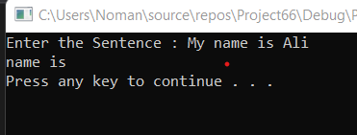

Task 2:

#include<iostream>

#include<string>

#include<cstring>

using namespace std;

int main()

{

char arr[10][100];

int num,count=0;

cout << "Enter the Number less than 10 :";//taking input//

cin >> num;

cin.clear();

fflush(stdin);

cin.ignore();

cout << "Enter the strings :" << endl;

for (int i = 0; i < num; i++)//taking input for arry //

{

cin.getline(arr[i], 100);

}

for (int i = 0; i < num; i++)

{

if (arr[i][0]!='A') //condition for A characcter//

{

cout << arr[i] << endl;

count++;

cout << endl;

}

}

cout << count << endl;//Displaying Count//

system("pause");

return 0;

}

Output:

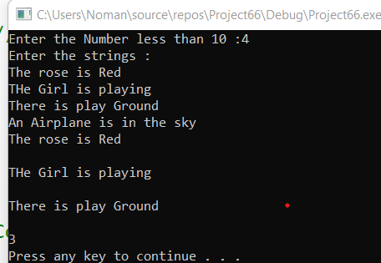

Task #3:

#include<iostream>

#include<string>

#include<cstring>

using namespace std;

int main()

{

char str1[15];//Declaration//

char str2[15] = "Good day";

//str1 = str2;//a part//we can not copy from str1 into str2. and also this is Invalid//

if (str1==str2)//b part//

{

cout << "both strings ae of same Length :" << endl;

}

if (strlen(str1)>=strlen(str2))//c part//

{

str1 = str2; //this is Invalid because we can not copy any string//

}

if (strcmp(str1,str2)<0)

{

cout << "str1 is less than str2 " << endl;

}

system("pause");

return 0;

}

Output:

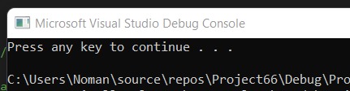

Task #4:

#include<iostream>

#include<string>

#include<cstring>

using namespace std;

int main()

{

char str1[21];

char str2[21];

int length;

string str1 = "sunny Day";//a part//

cout << str1;

//cout << str1.length();

system("pause");

return 0;

}